1st Grade Connection
December 8-12, 2025
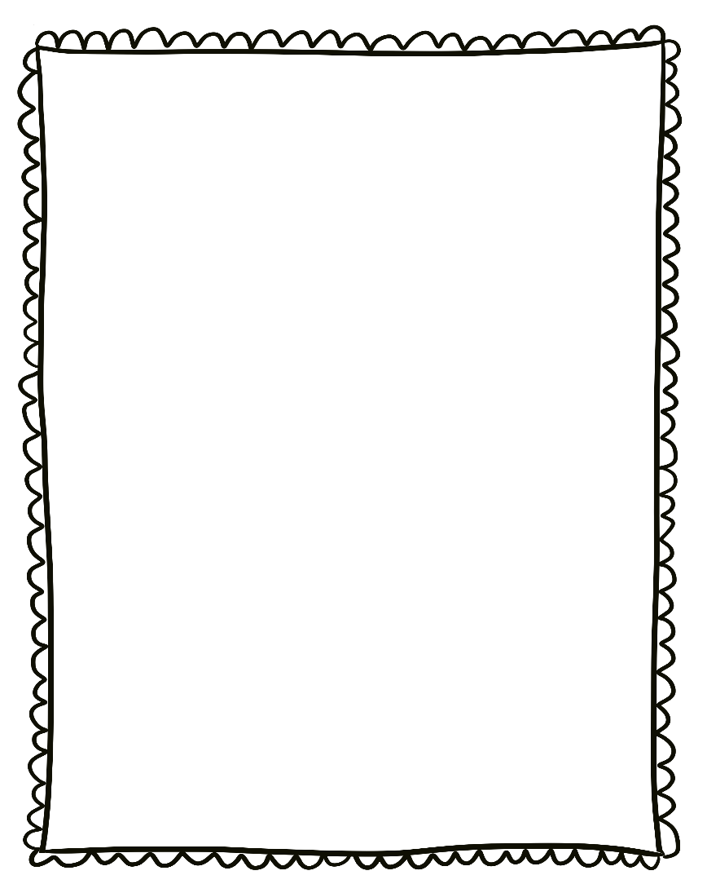
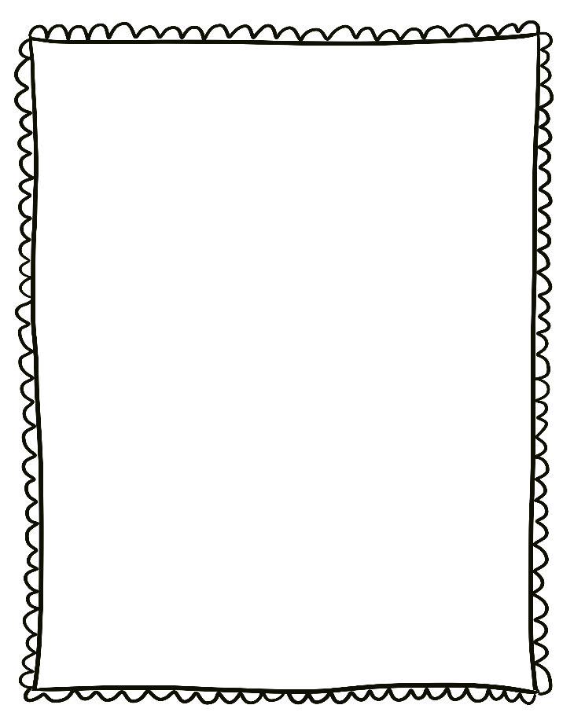
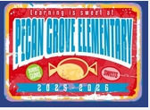
- Monday, December 8th: Divine Dress Up! Please see the calendar posted in Dojo!
- Monday, December 8^{-th}: Holiday Market all week!
- Saturday, December 13th: Breaksfast with Santa 9-11am

Reminders:

- Please send a nutritious snack that is easy to eat to school with your student. All snacks must be peanut free. Examples of this include Cheez-Its, Pretzels, or baby.
carrots.

- Wear tennis shoes on PE days!

- Reading: Non-fiction-central idea and details and text features

- Phonics: Consonant Blends -spl, -spr, -scr

- Writing: All About Books

- Conventions: Pronouns

- Math: 3D shapes

- Social Studies: Traditions and Culture

- Science: Soil

Upcoming Events/Grades
What we are learning:

